Smart Health Record System with Local LLM-Based Clinical History Summarization
Sneha M. Patil, Ved Rane, Vishwas Vala, Suyash Uttarwar, Vaibhav Mane, Atharv Varade
Department of Engineering, Sciences and Humanities (DESH)
Vishwakarma Institute of Technology, Pune, Maharashtra, India
Abstract — Healthcare institutions often face challenges in managing patient records efficiently due to fragmented paper-based documentation and the absence of centralized medical history systems. This can lead to delays in accessing patient information, difficulties in tracking previous consultations, and reduced efficiency during clinical decision-making. To address these challenges, this paper presents a Smart Health Record System with Local LLM-Based Clinical History Summarization. The proposed system is a web-based healthcare record management platform developed using Flask, SQLite, HTML, CSS, and JavaScript. It enables patient registration, doctor registration, doctor authentication, consultation management, and laboratory report storage within a centralized database. The system generates unique identifiers for patients, doctors, and consultations to facilitate efficient record retrieval and management. A key feature of the proposed solution is the integration of a local Large Language Model (LLM) through Ollama, which automatically generates concise summaries of a patient's consultation history. The summarization module analyzes chronological consultation records and provides doctors with a quick overview of recurring symptoms, diagnoses, treatments, and clinical observations. Since the AI model operates locally, patient data remains within the system, supporting privacy-oriented healthcare applications. The developed prototype demonstrates how artificial intelligence can be integrated with healthcare record systems to improve accessibility, organization, and review of medical information. The system serves as a lightweight and cost-effective solution suitable for academic research, small clinics, and healthcare information management studies.
Keywords — Artificial Intelligence, Clinical History Summarization, Flask, Healthcare Record Management, Local LLM, Ollama, Patient Data Management, SQLite.

INTRODUCTION
T
HE healthcare sector generates a large volume of patient information, including demographic details, consultation records, prescriptions, diagnostic reports, and treatment histories. In many small clinics and healthcare centers, these records are still maintained using paper-based files or fragmented digital systems. Such approaches often lead to difficulties in storing, retrieving, and analyzing patient information efficiently. Doctors may spend considerable time searching through previous records, which can delay clinical decision-making and affect the overall quality of healthcare services.
With the rapid advancement of information technology, healthcare organizations are increasingly adopting digital solutions to improve record management and accessibility. Health record management systems provide a centralized platform for storing and organizing patient information, enabling healthcare professionals to access medical histories quickly and accurately. However, merely storing records digitally does not completely solve the challenge of reviewing extensive consultation histories. As the number of patient visits increases, doctors may need to examine multiple records before understanding the overall health progression of a patient.
Recent developments in Artificial Intelligence (AI) and Large Language Models (LLMs) have opened new opportunities for intelligent healthcare applications. AI-powered summarization techniques can analyze large volumes of textual information and generate concise summaries that help users understand important details within a shorter time. Integrating such capabilities into healthcare record systems can significantly reduce the effort required to review patient histories and improve the efficiency of medical consultations.
To address these challenges, this paper presents a Smart Health Record System with Local LLM-Based Clinical History Summarization. The proposed system is a web-based healthcare record management platform developed using Flask, SQLite, HTML, CSS, and JavaScript. The system supports patient registration, doctor registration, doctor authentication, consultation management, medical history retrieval, and laboratory report management through a centralized database. Unique identifiers are automatically generated for patients, doctors, and consultation records, enabling efficient storage and retrieval of information.
A distinguishing feature of the proposed system is the integration of a local Large Language Model through Ollama. The AI module analyzes chronological consultation records and generates concise summaries of a patient's clinical history. These summaries provide doctors with a quick overview of recurring symptoms, diagnoses, treatments, and important medical observations. Since the model operates locally, patient information remains within the system environment, making the approach suitable for privacy-oriented healthcare applications and academic research.
The primary objectives of the proposed system are:
• To digitize and centralize healthcare records.
• To simplify patient and doctor record management.
• To maintain consultation histories and laboratory reports in an organized manner.
• To provide rapid access to patient medical information.
• To integrate AI-based clinical history summarization for efficient review of consultation records.
• To demonstrate a lightweight and cost-effective healthcare information management solution.
The developed prototype demonstrates how modern web technologies and local AI models can be combined to improve healthcare record accessibility and patient history analysis. The system provides a practical framework for exploring intelligent healthcare record management while maintaining simplicity, affordability, and ease of deployment.

Literature Review

Recent advancements in healthcare informatics and artificial intelligence have significantly transformed the management, accessibility, and analysis of healthcare records. Researchers have explored the use of Electronic Health Records (EHRs), Large Language Models (LLMs), privacy-preserving healthcare systems, and AI-driven clinical summarization techniques to improve healthcare efficiency and reduce the burden of medical documentation.
Naemi et al. [1] investigated the role of Large Language Models in optimizing clinical insights through text summarization. The study demonstrated that LLMs can effectively process large volumes of healthcare-related textual data and generate concise summaries that support clinical decision-making. The authors highlighted the potential of LLMs to reduce information overload for healthcare professionals. However, the work primarily focused on summarization techniques and did not address complete healthcare record management or consultation tracking systems.
Kahl et al. [2] evaluated an Electronic Health Record-integrated artificial intelligence chart review system designed to assist clinicians in analyzing patient records. Their findings indicated that AI-assisted chart reviews can significantly reduce the time required to review patient histories while maintaining clinical relevance. Although the study demonstrated the effectiveness of AI-assisted record analysis, it focused on evaluation of an integrated chart review solution rather than the development of a complete healthcare record management platform.
Lee et al. [3] examined the prospects of AI-based clinical summarization for reducing the burden of patient chart review. The study discussed how artificial intelligence can improve healthcare workflows by automatically generating concise summaries of lengthy medical records. The authors emphasized the potential benefits of AI in enhancing efficiency and reducing clinician workload. However, the work mainly provided a conceptual and analytical review rather than an implementation-oriented healthcare management system.
Chan et al. [4] developed an offline and open-source Electronic Health Record system intended for healthcare delivery in resource-constrained environments. Their system demonstrated the importance of affordable and accessible healthcare record management solutions, particularly in situations where internet connectivity is limited. While the proposed system successfully addressed record management challenges, it did not incorporate artificial intelligence-based clinical summarization capabilities.
Lee et al. [5] presented a comprehensive study on privacy-aware Large Language Models in healthcare applications. The research analyzed various privacy threats, security concerns, and privacy-preserving techniques associated with deploying LLMs in healthcare systems. The authors emphasized the importance of safeguarding sensitive patient information while utilizing advanced AI technologies. Their findings provide valuable insights for designing secure AI-assisted healthcare platforms.
Van Veen et al. [6] demonstrated that adapted Large Language Models can outperform medical experts in clinical text summarization tasks. The study evaluated multiple LLM architectures across different healthcare datasets and reported that appropriately fine-tuned models generated highly accurate and clinically relevant summaries. This work highlighted the growing potential of LLMs as intelligent assistants in healthcare environments and provided strong motivation for integrating AI-driven summarization into healthcare information systems.
Researchers in the Journal of Medical Internet Research (JMIR) [7] conducted a comprehensive review of prompt engineering paradigms for medical applications. The study emphasized the importance of prompt design in improving the accuracy, reliability, and contextual understanding of Large Language Models. The authors concluded that effective prompt engineering plays a crucial role in achieving high-quality outputs from AI systems in healthcare settings.
Sharma et al. [8] proposed a QR-based paperless outpatient health and consultation record sharing system aimed at improving healthcare record accessibility. The system utilized QR technology to facilitate efficient sharing and retrieval of patient information. Although the proposed solution successfully digitized healthcare records and improved information exchange, it lacked advanced artificial intelligence features such as automated summarization and intelligent clinical history analysis.
The reviewed literature demonstrates significant progress in healthcare record digitization, clinical summarization, artificial intelligence integration, and privacy-preserving healthcare technologies. However, most existing studies focus either on healthcare record management or AI-based summarization independently. Limited research has been conducted on integrating healthcare record management, consultation tracking, laboratory report management, and local AI-powered clinical history summarization within a single platform. The proposed Smart Health Record System addresses this gap by combining centralized healthcare record management with local LLM-based clinical summarization, thereby providing an integrated, privacy-oriented, and cost-effective healthcare information management solution.

Methodology/Experimental
A. System Architecture
The proposed Smart Health Record System is designed as a web-based healthcare record management platform that enables patient registration, doctor registration, consultation management, laboratory report handling, and AI-assisted clinical history summarization. The system follows a client-server architecture consisting of a user interface, backend processing layer, database layer, and AI summarization module.
The frontend is developed using HTML, CSS, and JavaScript to provide an interactive interface for patients and doctors. The backend is implemented using the Flask framework, which manages routing, authentication, data processing, consultation management, and communication with the database. SQLite is used as the database management system to store patient records, doctor information, consultation histories, and laboratory report references. The AI summarization module utilizes a locally deployed Large Language Model through Ollama to generate concise summaries of patient consultation histories.
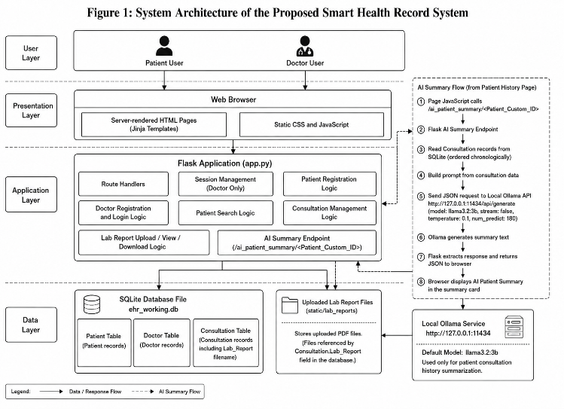
Figure 1: System Architecture of the Proposed Smart Health Record System
B. System Workflow
The workflow begins with patient and doctor registration. After successful registration, unique identifiers are generated for both entities. Doctors can log into the system using their credentials and search for patients using the generated patient identifier.
Once a patient is selected, the doctor can create a consultation record by entering complaints, symptoms, consultation notes, diagnosis, prescription details, and laboratory reports. The consultation information is stored in the centralized database and becomes available for future retrieval.
When a doctor requests a patient history review, the system retrieves all previous consultations associated with that patient. The consultation records are arranged chronologically and supplied to the AI summarization module. The local Large Language Model processes the records and generates a concise clinical summary, which assists doctors in understanding the patient's medical history efficiently.
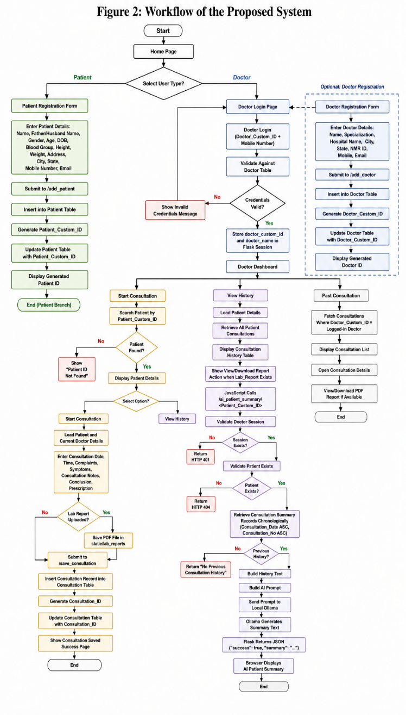
Figure 2: Workflow of the Proposed System
C. Database Design
The database is designed to maintain organized and structured healthcare information. The system contains three primary entities: Patient, Doctor, and Consultation.
The Patient table stores demographic and contact information of registered patients. The Doctor table maintains professional and contact details of registered doctors. The Consultation table stores medical consultation records, including symptoms, diagnosis, prescriptions, consultation notes, and laboratory report references.
The Consultation entity acts as a bridge between Patient and Doctor entities, establishing logical relationships between healthcare providers and patients. This design enables efficient retrieval of patient history and doctor-specific consultation records.
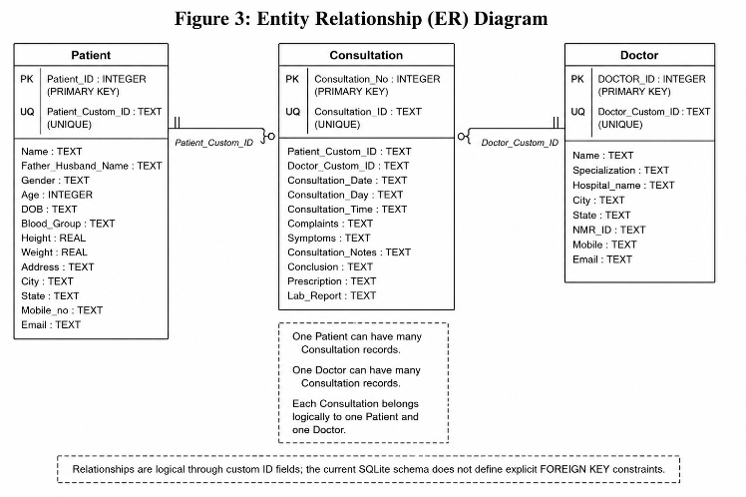
Figure 3: Entity Relationship Diagram
D. AI-Based Clinical History Summarization
The AI summarization module is a key component of the proposed system. When a doctor requests a patient summary, the system retrieves all consultation records related to the selected patient in chronological order. Relevant information such as consultation date, symptoms, complaints, consultation notes, diagnosis, and prescriptions is extracted and formatted into a structured textual representation.
The generated text is supplied to a locally deployed Large Language Model through Ollama. A carefully designed prompt instructs the model to generate a concise clinical summary while maintaining chronological order and avoiding unsupported assumptions. The generated summary provides a quick overview of recurring symptoms, treatments, diagnoses, and important clinical observations.
Since the summarization process is executed locally, patient information remains within the system environment, thereby supporting privacy-oriented healthcare applications.
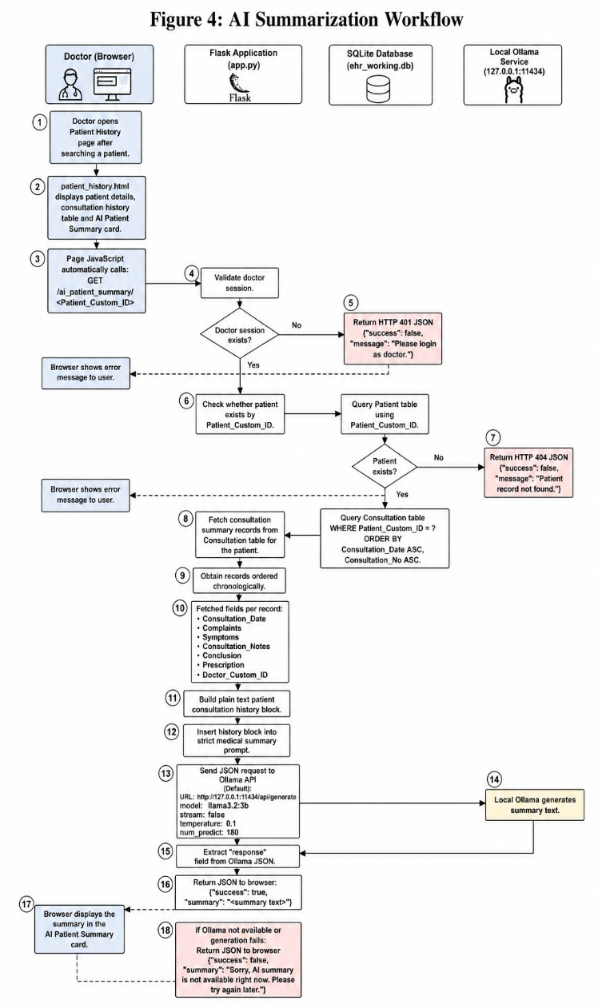
Figure 4: AI Summarization Workflow
E. Algorithm
Algorithm 1: Patient Consultation Summarization
Step 1: Authenticate the doctor session.
Step 2: Retrieve patient details using Patient ID.
Step 3: Fetch all consultation records associated with the patient.
Step 4: Arrange consultation records chronologically.
Step 5: Extract complaints, symptoms, consultation notes, diagnoses, and prescriptions.
Step 6: Construct a structured prompt containing patient history.
Step 7: Send the prompt to the local Large Language Model through Ollama.
Step 8: Generate a concise clinical summary.
Step 9: Display the generated summary to the doctor.
Step 10: End process.
F. Experimental Setup
The proposed system was implemented using Python Flask as the backend framework and SQLite as the database management system. HTML, CSS, and JavaScript were used for frontend development. The AI summarization module was integrated using Ollama with the Llama 3.2:3B model running locally.
The experimental evaluation focused on validating patient registration, doctor registration, consultation creation, laboratory report management, patient history retrieval, and AI-based summarization functionalities. Multiple test scenarios were executed to verify data storage, retrieval accuracy, consultation management, and summary generation performance.

Unique identifier generation mechanism
Efficient identification and retrieval of healthcare records are essential for maintaining data consistency and reducing ambiguity in healthcare information systems. To ensure that each entity within the proposed Smart Health Record System can be uniquely identified, the system automatically generates custom identifiers for patients, doctors, and consultation records. These identifiers are created using predefined formats that combine meaningful information with system-generated serial numbers.
- Patient ID Generation
A unique Patient ID is generated immediately after successful patient registration. The generated identifier combines a fixed prefix, selected characters from the patient's name, selected characters from the date of birth, and a unique serial number assigned by the database. This approach ensures uniqueness while maintaining human readability.
Patient ID Format:
P0 + Name Part + DOB Part + Serial Number
Example:
P0RA200005
where:
- P0 represents the patient prefix.
- RA represents the first two characters of the patient's name.
- 20 represents the first two digits extracted from the date of birth.
- 0005 represents the database-generated serial number.
- Doctor ID Generation
A unique Doctor ID is generated when a doctor completes the registration process. The identifier is constructed using a fixed prefix, characters extracted from the doctor's name, characters extracted from the specialization field, and a unique serial number generated by the database.
Doctor ID Format:
D0 + Name Part + Specialization Part + Serial Number
Example:
D0CACA0001
where:
- D0 represents the doctor prefix.
- CA represents characters extracted from the doctor's name.
- CA represents characters extracted from the specialization.
- 0001 represents the database-generated serial number.
- Consultation ID Generation
Each consultation record receives a unique Consultation ID after successful consultation submission. The identifier consists of a consultation prefix, consultation date information, and a consultation serial number. This enables quick identification and tracking of consultation records within the system.
Consultation ID Format:
T0 + DDMM + Consultation Number
Example:
T020050001
where:
- T0 represents the consultation prefix.
- 2005 represents the consultation date in DDMM format.
- 0001 represents the consultation sequence number.
The proposed identifier generation mechanism provides a structured and efficient approach for managing healthcare records. The generated identifiers are unique, easily interpretable, and simplify record retrieval across different modules of the Smart Health Record System.

System requirements
The proposed Smart Health Record System was developed and tested using commonly available hardware and software resources. The system is designed to be lightweight and can be deployed on standard personal computers without requiring specialized infrastructure. The requirements used during development and testing are described below.
- Hardware Requirements
The minimum hardware requirements for successful deployment and execution of the system are:
• Processor: Intel Core i3/i5 or equivalent processor
• RAM: Minimum 8 GB
• Storage: Minimum 2 GB available disk space
• Display: Standard monitor with minimum resolution of 1366 × 768
• Network: Internet connection required for software installation and updates
- Software Requirements
The software components used for implementation of the proposed system are as follows:
• Operating System: Windows 10/11, Linux, or macOS
• Programming Language: Python 3.x
• Backend Framework: Flask
• Database Management System: SQLite
• Frontend Technologies: HTML, CSS, and JavaScript
• AI Framework: Ollama
• AI Model: Llama 3.2:3B
• Web Browser: Google Chrome, Microsoft Edge, or Mozilla Firefox
- Development Environment
The system was developed using Visual Studio Code as the primary development environment. Database operations were managed through SQLite, while Flask handled application routing, session management, and backend processing. The Ollama framework was integrated to enable local Large Language Model-based clinical history summarization.
The lightweight nature of the selected technologies makes the proposed system suitable for academic projects, research demonstrations, and small healthcare facilities requiring an affordable healthcare record management solution.

Results and Discussions
The proposed Smart Health Record System was successfully designed and implemented using Flask, SQLite, HTML, CSS, JavaScript, and a locally deployed Large Language Model through Ollama. The system integrates patient management, doctor management, consultation recording, laboratory report handling, and AI-assisted clinical history summarization within a unified platform. The experimental evaluation focused on validating the functionality and reliability of each module.
A. Patient Registration and Record Management
The patient registration module successfully stores demographic and contact information in the database and automatically generates a unique Patient ID for each registered patient. The generated identifier enables efficient retrieval of patient records during future consultations. The centralized storage of patient information reduces dependence on paper-based records and improves accessibility.
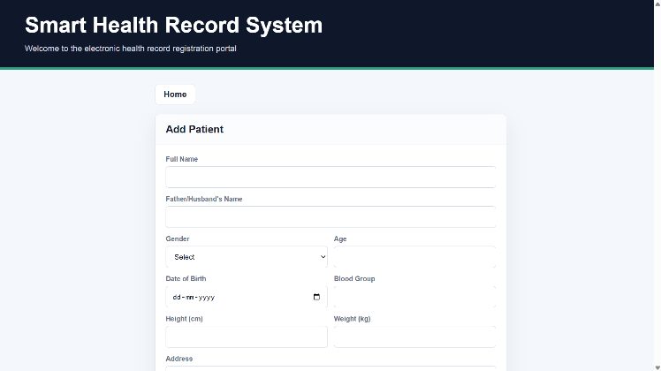
Figure 5: Patient Registration Module
B. Doctor Registration and Authentication
The doctor management module allows healthcare professionals to register and obtain a unique Doctor ID. The authentication mechanism successfully validates doctor credentials and restricts access to consultation-related functionalities. The implemented session management mechanism ensures that only authenticated doctors can access patient history and consultation records.
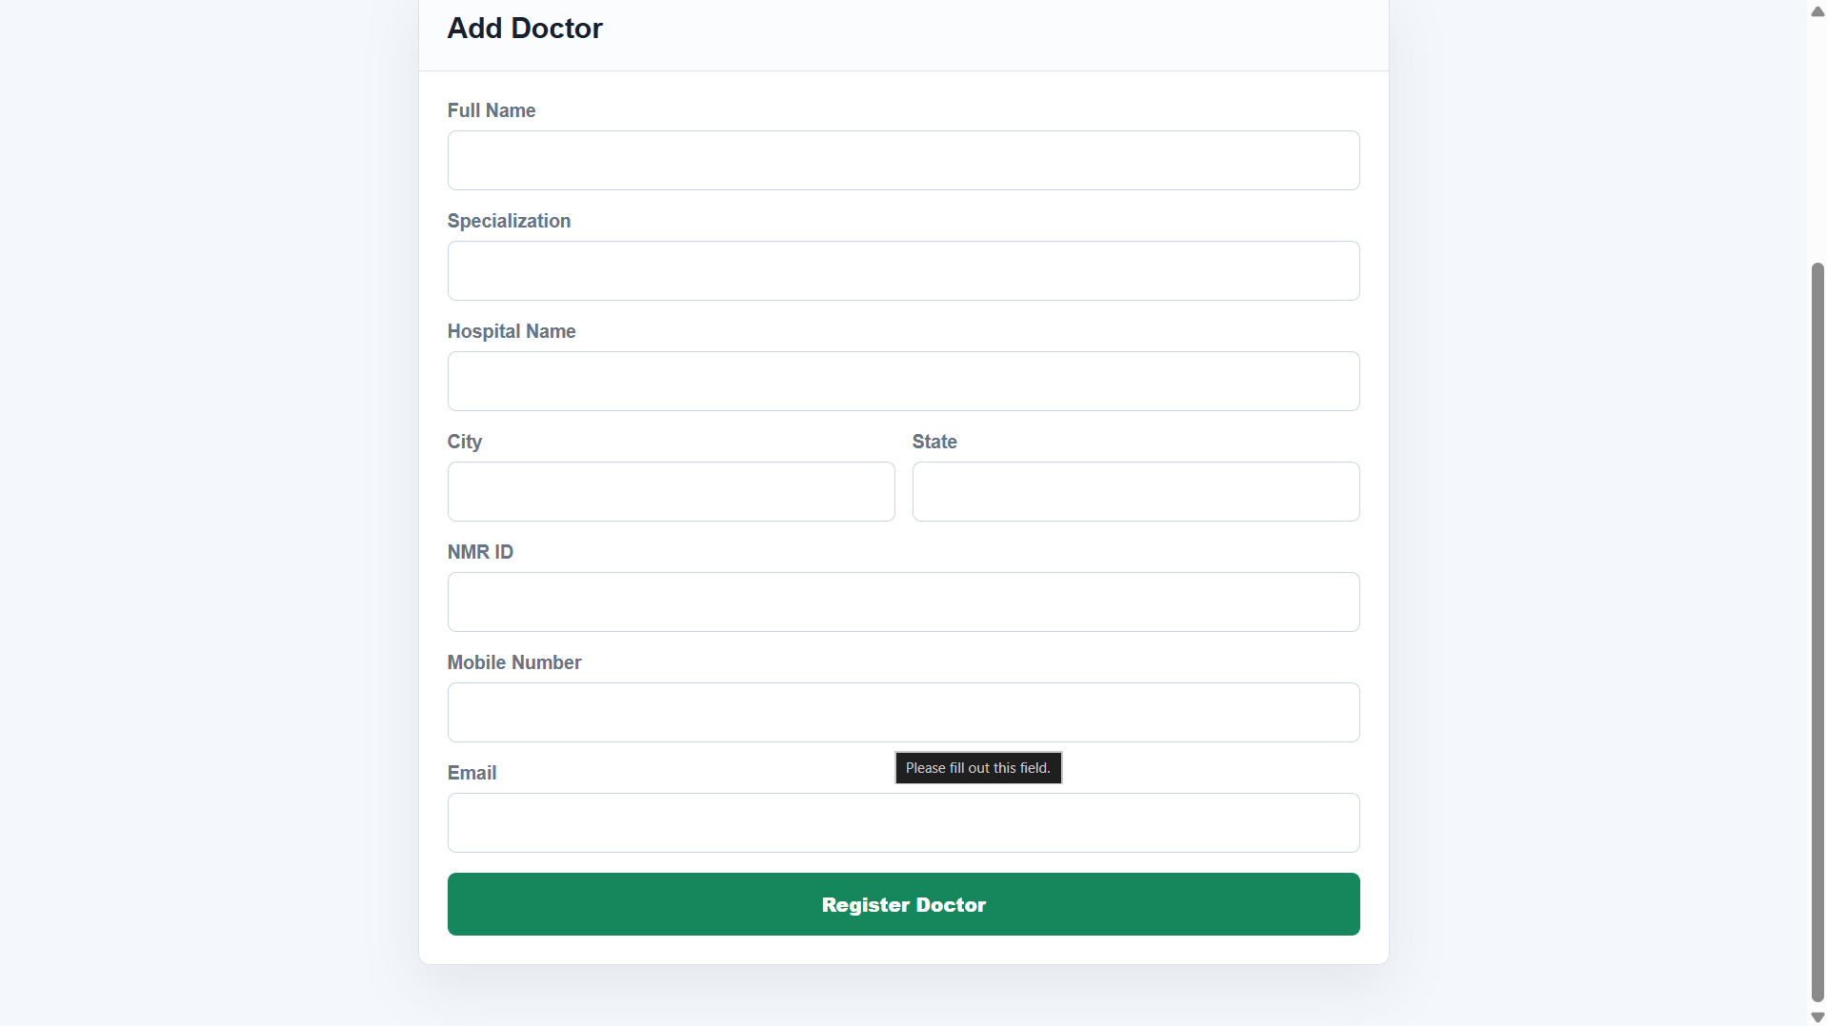
Figure 6: Doctor Login and Dashboard
C. Consultation Management
The consultation module successfully records consultation date, time, symptoms, complaints, clinical observations, diagnosis, and prescriptions. The generated consultation records are stored in the database and can be retrieved whenever required. A unique consultation ID is also generated for each transaction. The system maintains chronological consultation histories, allowing doctors to review previous patient interactions efficiently.
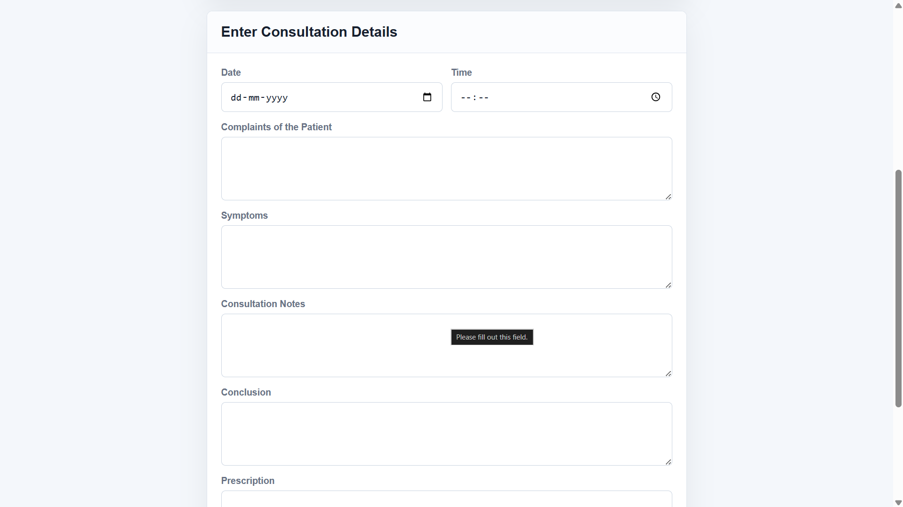
Figure 7: Consultation Entry Form
D. Laboratory Report Management
The laboratory report management module enables doctors to upload PDF-based laboratory reports during consultation creation. Uploaded reports are stored securely and can be viewed or downloaded from the patient history interface. This functionality provides a centralized repository for supporting medical documents and simplifies access to diagnostic information.
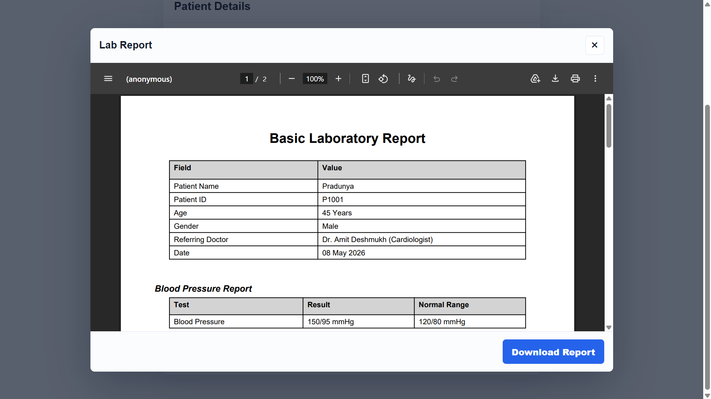
Figure 8: Laboratory Report Viewing Interface
E. Patient History Retrieval
The patient history module successfully retrieves all consultations associated with a particular patient. The retrieved records are displayed in an organized manner, enabling doctors to review consultation details, diagnoses, prescriptions, and associated laboratory reports. The centralized history view improves continuity of care and reduces the effort required to locate previous records.
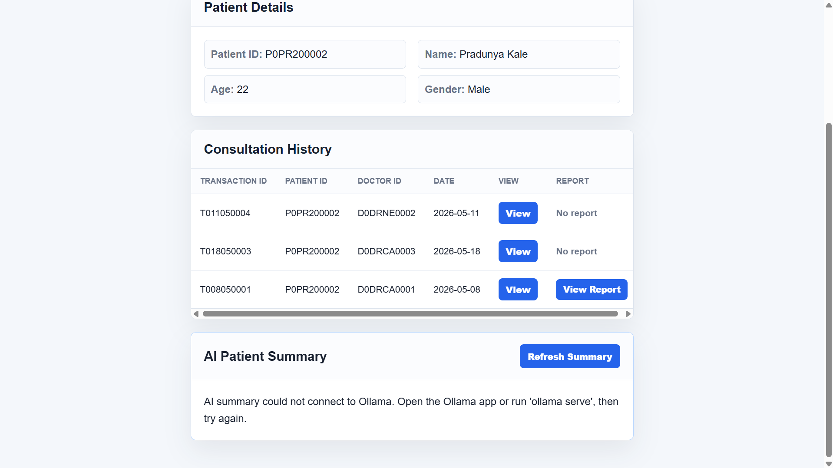
Figure 9: Patient History Screen
F. AI-Based Clinical History Summarization
One of the major outcomes of the project is the successful integration of a local Large Language Model for clinical history summarization. The system retrieves consultation records chronologically and generates concise summaries that highlight recurring symptoms, diagnoses, treatments, and significant clinical observations. The generated summaries assist doctors in understanding patient history without manually reviewing every consultation record.
The use of a locally deployed model through Ollama ensures that medical information remains within the system environment, reducing dependence on external cloud-based services and supporting privacy-oriented healthcare applications. The generated summaries were observed to provide a coherent overview of patient history while preserving the chronological sequence of consultations.
G. Discussion
The developed system demonstrates that modern web technologies can be effectively combined with local artificial intelligence models to enhance healthcare record management. The integration of patient registration, consultation management, laboratory report handling, and AI-assisted summarization within a single platform improves information accessibility and reduces the time required for reviewing historical patient data.
Compared to traditional paper-based record systems, the proposed solution offers faster information retrieval, improved organization of healthcare records, and intelligent summarization capabilities. The use of a lightweight architecture based on Flask and SQLite makes the system suitable for academic demonstrations, small healthcare facilities, and research-oriented healthcare applications.
The experimental results indicate that the proposed system successfully achieves its primary objectives of centralized record management and AI-assisted consultation history review while maintaining simplicity, affordability, and ease of deployment.

Limitations of the proposed system
Although the proposed Smart Health Record System successfully demonstrates centralized healthcare record management and AI-assisted clinical history summarization, certain limitations exist in the current implementation. These limitations provide opportunities for future research and system enhancement.
A. Limited Scalability
The current implementation utilizes SQLite as the database management system. While SQLite is lightweight and suitable for academic projects and small-scale deployments, it may not efficiently support a large number of concurrent users or large-scale healthcare infrastructures. Future deployments would require more robust database solutions capable of handling high transaction volumes and distributed access.
B. Basic Security Mechanisms
The present system focuses primarily on functionality and proof-of-concept implementation. Advanced security features such as multi-factor authentication, role-based access control, database encryption, and comprehensive audit logging have not been fully implemented. These features are essential for deployment in real-world healthcare environments where sensitive patient information must be protected.
C. Dependence on Structured Data Entry
The quality of healthcare records and generated summaries depends heavily on the accuracy and completeness of data entered by healthcare professionals. Incomplete or inconsistent consultation records may affect the usefulness of retrieved information and AI-generated summaries.
D. Limited AI Context Understanding
The AI summarization module is designed to generate concise summaries of consultation histories. However, the generated summaries should not be interpreted as medical diagnoses or treatment recommendations. Clinical decisions must always remain under the supervision of qualified healthcare professionals.
E. Absence of Interoperability Support
The current system operates as a standalone platform and does not provide direct integration with external hospital information systems, laboratory systems, insurance platforms, or national healthcare databases. Interoperability standards would be required for broader adoption in healthcare ecosystems.
F. Limited Mobile Accessibility
The system is primarily designed as a web-based application. Although accessible through web browsers, a dedicated mobile application has not been developed. Mobile support could improve accessibility for both healthcare professionals and patients.
Despite these limitations, the proposed system successfully demonstrates the feasibility of integrating healthcare record management with local AI-powered clinical history summarization. The identified limitations provide valuable directions for future development and enhancement of the platform.

Helpful Hints
To ensure efficient utilization of the proposed Smart Health Record System, healthcare professionals should follow certain best practices while entering and managing healthcare records. Proper usage of the system improves record accuracy, consultation tracking, and AI-generated summary quality.
A. Accurate Data Entry
Patient demographic details, consultation notes, symptoms, diagnoses, and prescriptions should be entered carefully and accurately. Complete and well-structured records improve the reliability of future retrieval and clinical summarization.
B. Consistent Consultation Documentation
Doctors should maintain a consistent format while recording consultation details. Clearly documented symptoms, observations, diagnoses, and prescribed treatments help generate more informative patient history summaries.
C. Proper Laboratory Report Management
Uploaded laboratory reports should be appropriately named and associated with the correct consultation records. This facilitates efficient retrieval and review of supporting medical documents during future consultations.
D. Regular Review of Patient History
Before initiating a new consultation, doctors should review previous consultation records and AI-generated summaries. This practice helps maintain continuity of care and supports informed clinical decision-making.
E. Verification of AI-Generated Summaries
Although the AI summarization module provides concise clinical summaries, healthcare professionals should verify important medical information by reviewing the original consultation records whenever necessary. AI-generated summaries should be used as a supporting tool rather than a replacement for professional medical judgment.
F. Data Security and Privacy
Access to the system should be limited to authorized users. Patient identifiers and consultation information should be handled responsibly to maintain confidentiality and protect sensitive healthcare data.
By following these guidelines, users can maximize the effectiveness of the Smart Health Record System while ensuring accurate record management, efficient consultation review, and reliable AI-assisted clinical summarization.

Future Scope
The proposed Smart Health Record System successfully demonstrates the integration of healthcare record management with local AI-based clinical history summarization. While the current implementation serves as a functional prototype, several enhancements can be incorporated to improve security, scalability, interoperability, and intelligent healthcare support.
A major area of future development is security enhancement. The current system can be upgraded with advanced authentication and authorization mechanisms such as password hashing, multi-factor authentication, role-based access control, and encrypted database storage. Secure communication protocols and audit logging mechanisms can also be implemented to ensure confidentiality, integrity, and accountability of sensitive healthcare information. These improvements would make the system more suitable for deployment in real-world healthcare environments.
Another significant future direction is the development of a centralized national-level health record platform. Instead of maintaining records within individual healthcare facilities, the system can be expanded into a unified healthcare information network where patient records are accessible across hospitals, clinics, diagnostic centers, and healthcare institutions through secure authorization mechanisms. A centralized architecture would enable healthcare professionals to access complete patient histories regardless of the location of previous treatments, thereby improving continuity of care and reducing duplication of medical procedures. Such a framework could contribute toward the realization of nationwide digital healthcare ecosystems.
The artificial intelligence capabilities of the system can also be substantially enhanced. Future versions may integrate advanced medical language models capable of generating more detailed clinical insights, identifying recurring disease patterns, and providing intelligent decision-support recommendations. AI modules can be trained to analyze longitudinal patient histories, detect risk factors, and highlight abnormal trends that require medical attention.
Integration with Optical Character Recognition (OCR) technology can further extend the system's capabilities. This would enable automatic extraction of information from uploaded laboratory reports, prescriptions, and medical documents. The extracted information could then be incorporated into the AI summarization process, resulting in more comprehensive patient assessments.
Future implementations may also support interoperability with national healthcare standards and digital health infrastructures. Standardized data exchange mechanisms would enable seamless communication between different healthcare systems, laboratories, pharmacies, and insurance providers. Such interoperability would improve healthcare coordination and facilitate efficient information sharing among authorized stakeholders.
Additional enhancements may include cloud deployment, real-time backup and recovery mechanisms, telemedicine integration, appointment scheduling, patient portals, mobile applications, healthcare analytics dashboards, and predictive healthcare monitoring systems. These features would transform the proposed platform from an academic prototype into a scalable and intelligent healthcare information management ecosystem.
Overall, the proposed Smart Health Record System provides a strong foundation for future research in secure healthcare data management, nationwide digital health infrastructure, and AI-assisted clinical decision support systems.

Conclusion
The Smart Health Record System with Local LLM-Based Clinical History Summarization presents a practical approach for improving healthcare record management through the integration of modern web technologies and artificial intelligence. The proposed system successfully provides a centralized platform for patient registration, doctor registration, consultation management, laboratory report handling, and medical history retrieval. By digitizing healthcare records and organizing them within a structured database, the system simplifies information storage, retrieval, and management.
A significant contribution of the proposed work is the integration of a locally deployed Large Language Model for clinical history summarization. The AI module analyzes chronological consultation records and generates concise summaries that assist healthcare professionals in understanding a patient's medical history more efficiently. The use of a local AI framework helps maintain data privacy while demonstrating the potential of intelligent healthcare applications.
The developed prototype validates the feasibility of combining healthcare record management with AI-assisted information processing in a lightweight and cost-effective environment. Experimental evaluation confirmed the successful implementation of patient management, consultation tracking, laboratory report management, and AI-based summarization functionalities. The system provides improved accessibility to healthcare information and reduces the effort required to review historical patient records.
Overall, the proposed Smart Health Record System establishes a strong foundation for future research in healthcare informatics, intelligent medical record management, and AI-assisted clinical decision support. The project demonstrates how emerging artificial intelligence technologies can enhance healthcare information systems and contribute toward more efficient and data-driven healthcare services.

X I. Acknowledgment
The authors express their sincere gratitude to our project guide, Sneha M. Patil, Department of Engineering, Sciences and Humanities (DESH), Vishwakarma Institute of Technology, Pune, for providing valuable guidance, continuous encouragement, and constructive suggestions throughout the development of this project and preparation of this research paper.
We would also like to thank the faculty members and staff of the Department of Engineering, Sciences and Humanities for their support and assistance during the course of this work. Their technical insights and academic guidance contributed significantly to the successful completion of the project.
The authors are grateful to Vishwakarma Institute of Technology, Pune, for providing the necessary facilities, resources, and learning environment required for carrying out this research and development work.
Finally, we extend our appreciation to all team members whose dedication, cooperation, and collective efforts made the successful implementation of the Smart Health Record System with Local LLM-Based Clinical History Summarization possible.

References
- "The Role of LLMs for Optimizing Clinical Insights in Text Summarization" – Springer Nature, 2024.
- "Evaluation of Electronic Health Record-Integrated Artificial Intelligence Chart Review" – npj Health Systems, 2026.
- "Prospects for AI Clinical Summarization to Reduce the Burden of Patient Chart Review" – Frontiers in Digital Health, November 2024.
- "Development of an Offline, Open-Source, Electronic Health Record System for Refugee Care" – Frontiers in Digital Health, March 2022.
- "SoK: Privacy-aware LLM in Healthcare: Threat Model, Privacy Techniques, Challenge”
- "Adapted Large Language Models Can Outperform Medical Experts in Clinical Text Summarization" – Van Veen, D. et al. – Nature Medicine, Vol. 30, 2024.
- "Prompt Engineering Paradigms for Medical Applications: Scoping Review" – Journal of Medical Internet Research (JMIR), 2024.
- "QR Based Paperless Out-Patient Health and Consultation Records Sharing System" – Springer, Lecture Notes in Networks and Systems, Vol. 256, 2021.

